SUBMITTED BY :
NAME : ZISHNENDU SARKER
ROLL NO.: 2K19/CO/450
SUBJECT : OOP LAB
LAB ASSIGNMENT NO. : 03

SUBMITTED TO :
DIKSHA RUHELA MAM
LAB2 NO. : 3

LAB NAME :

Write a program to add two time objects (in the form hh:mm).
Class name : Time
member variable : hours, minute
member function : sum, display
use constructor for initializing the value.
use objects of the class to find the sum.

CODE:

#include <iostream>
using namespace std;

class Time
{
private:
int hours;
int minutes;

public:
Time(){}
Time(int hh,int mm){
hours= hh;
minutes=mm;
}
void disp(void);
void sum(Time T1,Time T2);
};

void Time::disp(void)
{
cout << endl;
cout << "Time after summation : ";
cout << hours << ":" << minutes <<":" << endl;
}

void Time::sum(Time T1,Time T2)
{
this->minutes=T1.minutes+T2.minutes ;
this->hours= T1.hours+T2.hours + (this->minutes/60);
this->minutes %=60;
}

int main()
{
int h1,m1,h2,m2;
cout<<" Enter 1st time : \n";
cout<<" Hours : " ;
cin>>h1;
cout<<" Minutes : ";
cin>>m1;
cout<<" Enter 2nd time : \n";
cout<<" Hours : " ;
cin>>h2;
cout<<" Minutes : ";
cin>>m2;
Time T1(h1,m1);
Time T2(h2,m2);
Time T3;
T3.sum(T1,T2);
T3.disp();

return 0;
}

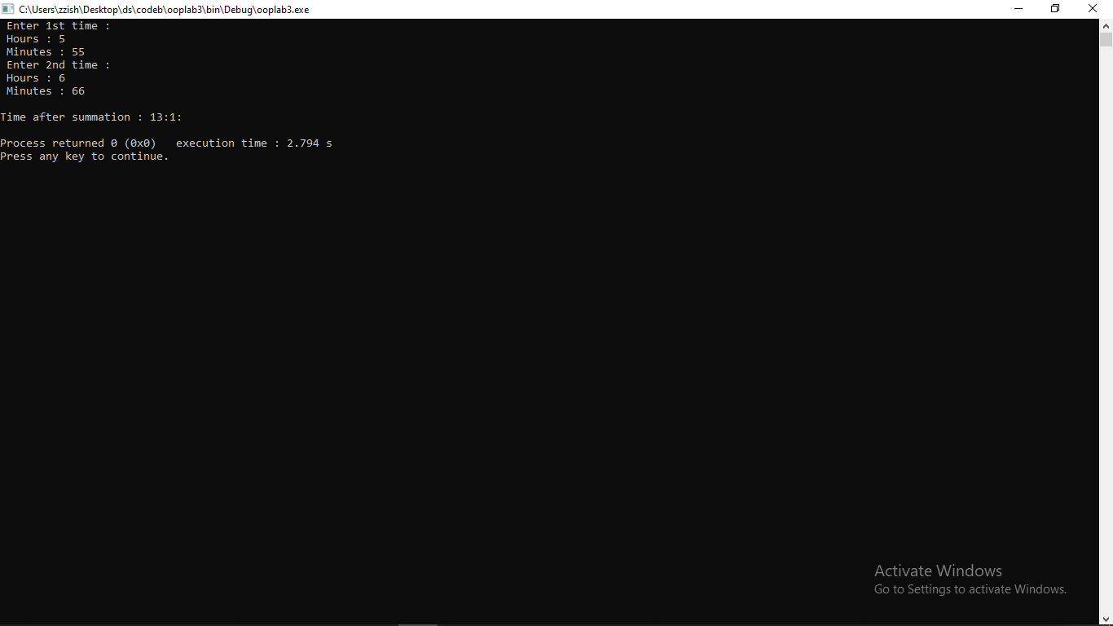
OUTPUT :

